Gym Ontology Design and Implementation
Submitted By: Fahamidul Hasan
GitHub: https://github.com/MarSsyy/gym-ontology

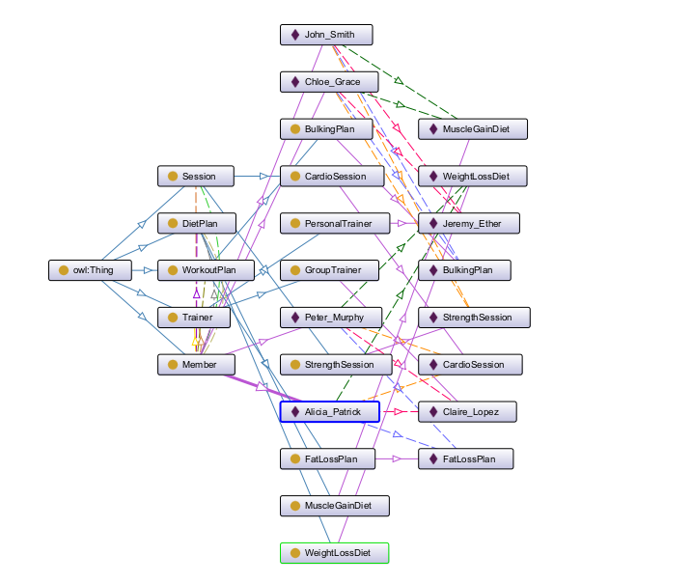
Figure 1: Ontograph of the overall system.

Classes and Sub Classes
The ontology consists of 5 main classes along with several subclasses:
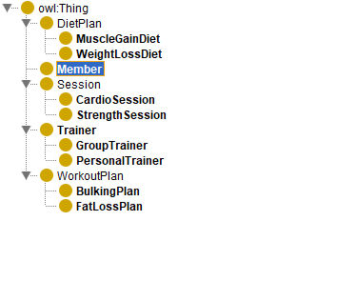

Object Properties
The relationships between individuals are defined using object properties:
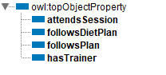
These properties link members to trainers, sessions, workout plans, and diet plans.

Data Properties
Data properties are used to store information about members:
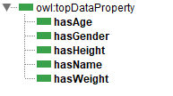

Individuals
Multiple individuals were created including:
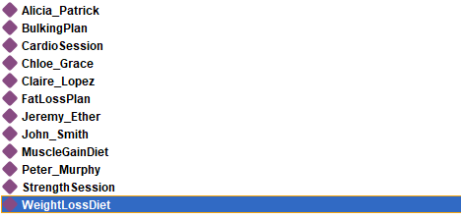

Each member is connected to relevant entities using object property assertions and information regarding each member is stored using data property assertions.
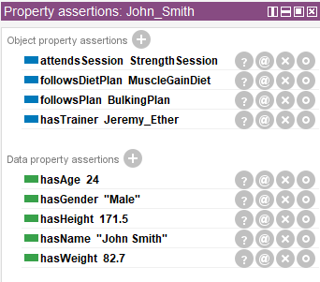

Disjointness
Disjoint constraints were defined to ensure consistency of logic:
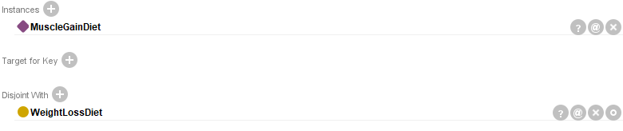
This ensures that MuscleGainDiet and WeightLossDiet are disjoint classes.
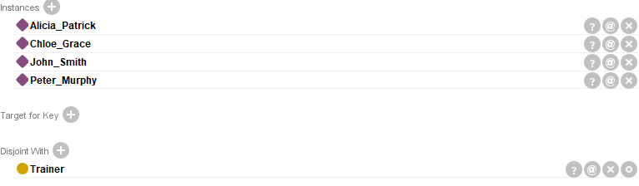
This ensures that Members cannot be Trainers.
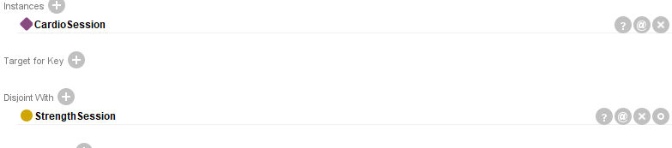
This ensures that CardioSession and StrengthSession are disjoint classes.
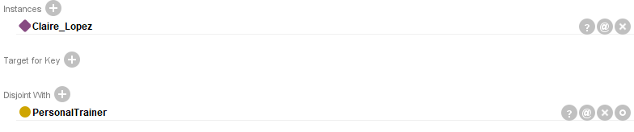
This ensures that GroupTrainer cannot be PersonalTrainer.
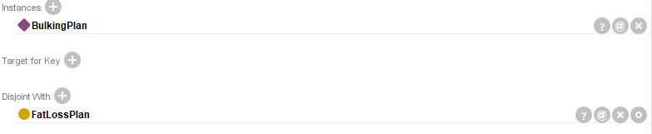
This ensures that BulkingPlan and FatLossPlan are disjoint classes.

Cardinality Restrictions
Some cardinality restrictions were also added to ensure that all members are properly assigned:
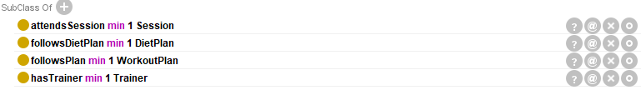
This ensures that members have at least one trainer, a workout plan, a diet plan as well as a session.

Reasoner
The HermiT reasoner was used to verify the ontology and the ontology was successfully generated without any inconsistencies.
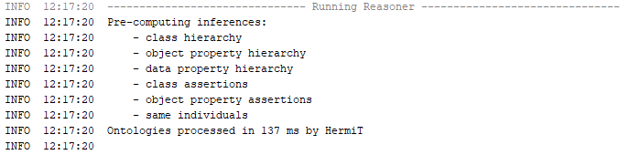

Queries Table
Screenshot | Description
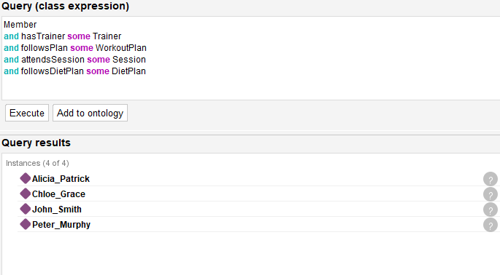 | Checks that all members satisfy required relationships [Relationship Validation]
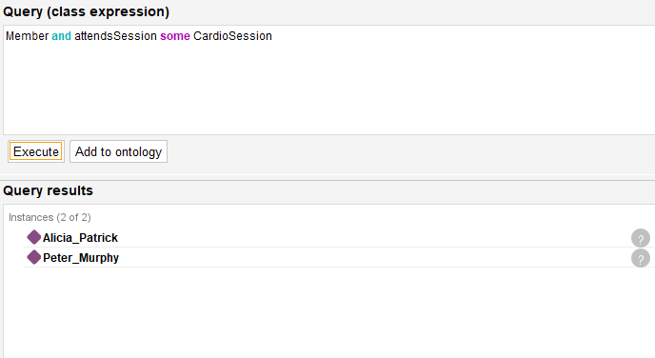 | Returns the list of members  that attend CardioSession [Sub Class Validation]
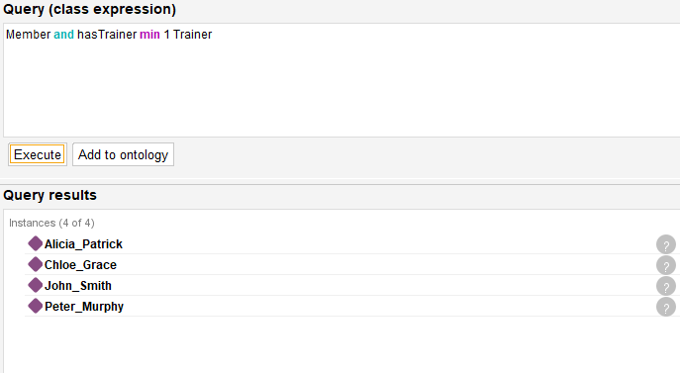 | Returns the list of members  that has at least one trainer [Cardinality Validation]
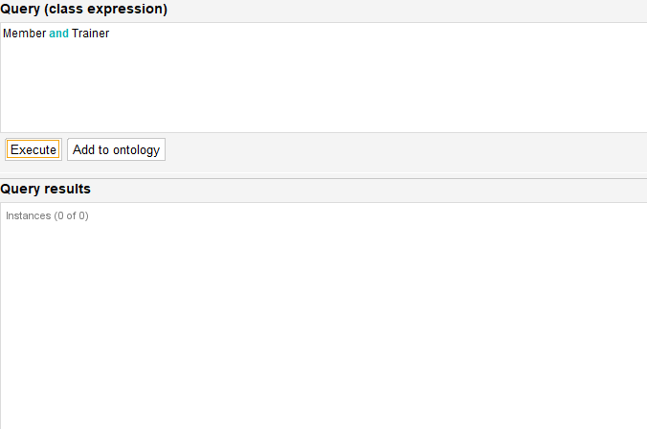 | Returns the list of members that are also trainers at the same time [Disjointness Validation]
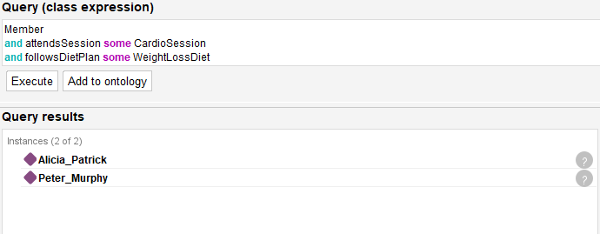 | Returns the list of members that attend CardioSession while following WeightLossDiet.

Reusability
The ontology can be reused in other applications within the domain of fitness/gym/health management systems. It can also be extended with additional classes and properties for more complex scenarios.

